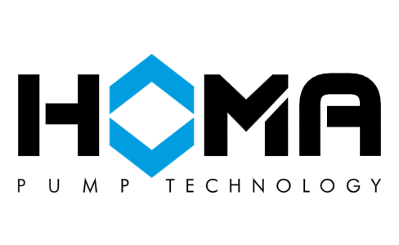

HOMA Pump Technology: Official Global Website

Submersible pumps for sewage and effluent
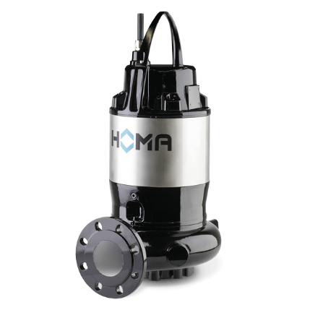
Submersible sewage pumps with single channel impeller
Spherical clearance : 80 - 100 mm
Discharge size : DN 80 / DN 100 / DN150
Max. head : 4,8 - 42,2 m
Max. flow : 72,0 - 390,0 m³/h
Motor power P1 : 1,7 - 43,0 kW
Motor power P2 : 0,0 - 25,4 kW
Speed : 2900 / 1450 / 960 rpm

V(X) - Submersible pumps for sewage and effluent
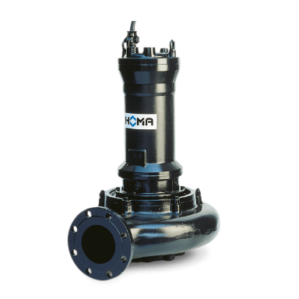
Submersible sewage pumps with vortex impeller
Spherical clearance : 80 - 100 mm
Discharge size : DN80 - DN100
Max. head : 7,0 - 53,8 m
Max. flow : 54,0 - 228,0 m³/h
Motor power P2 : 1,3 - 25,4 kW
Speed : 2900 / 1450 / 960 rpm

CMX(S) - Stainless steel sewage pumps
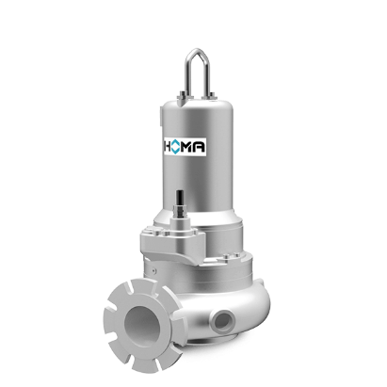
Submersible sewage pumps with single channel impeller
Spherical clearance : 80 - 100 mm
Discharge size : DN 80 / DN 100 / DN150
Max. head : 2,0 - 42,1 m
Max. flow : 68,2 - 384,1 m³/h

